**Ideation Phase**

**Brainstorm & Idea Prioritization Template**

|  |  |
| --- | --- |
| Date | 31 January 2025 |
| Team ID | PNT2025TMID02554 |
| Project Name | Global malnutrition trends analysis 1983 to 2019 |
| Maximum Marks | 4 Marks |

**Brainstorm & Idea Prioritization Template:**

Reference: <https://www.mural.co/templates/brainstorm-and-idea-prioritization>

**Step-1: Team Gathering, Collaboration and Select the Problem Statement**

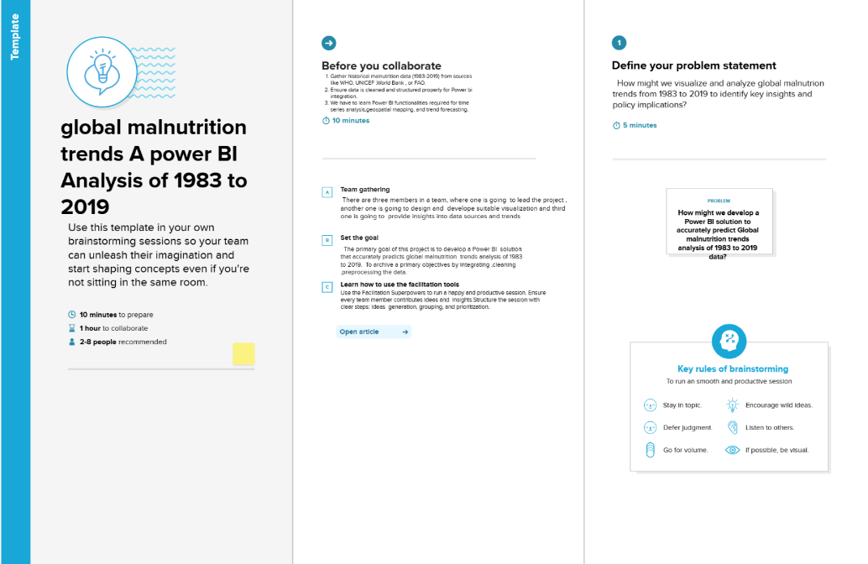

**Step-2: Brainstorm, Idea Listing and Grouping**

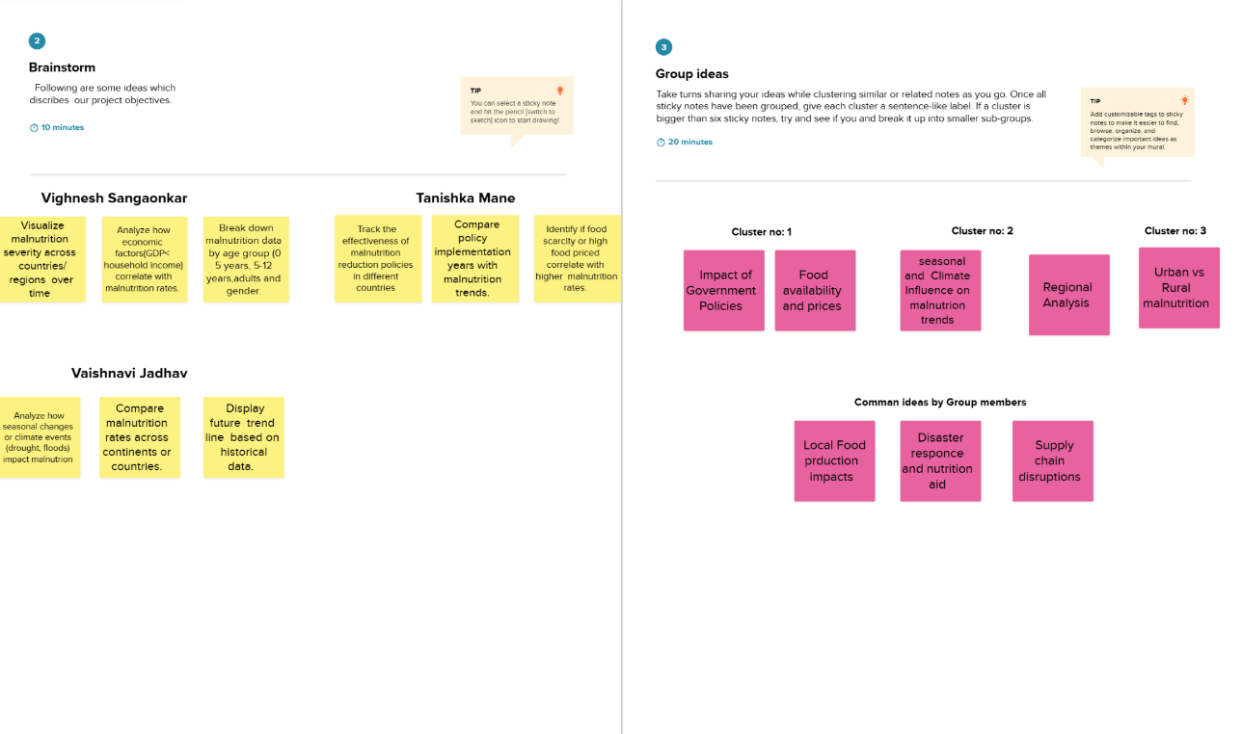

**Step-3: Idea Prioritization**

